#### WEX 12A/12B are courses offered to Grade 11 and 12 students and is a part of Delta’s Career Preparation program

#### Why take WEX 12A/12B?

#### Benefits of Work Experience (WEX) 12A/12B

* You gain 90 hours work experience in career field of choice
* You can use WEX hours to fulfill the 30 hours Work Experience /Community Service for Grad Transitions
* You receive the opportunity to develop employability skills
* You receive valuable real world feedback through employer assessment
* You can receive references and possible part-time or full-time employment



**Burnsview Secondary School**

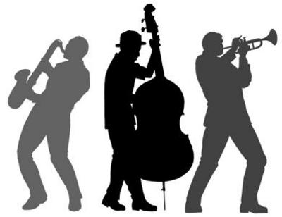

**For more information**

**Visit the website:**

[**www.bucareerprograms.weebly.com**](http://www.bucareerprograms.weebly.com)

**or contact:**

Virginia Dean, PhD

Career Programs Facilitator

vdean@deltasd.bc.ca

p. 604-594-0491 ext. 258

f. 604-594-0491

Burnsview Secondary

7658-112 Street

Delta, BC

V4C 4V8

Focus Area:

Fine Arts, Design, and Media

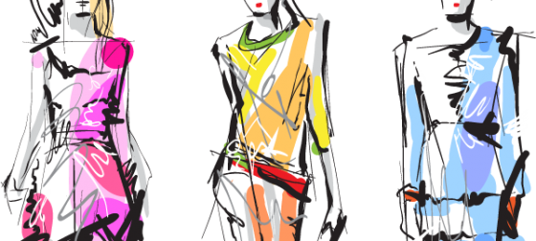

Career Preparation Program

Courses:

Work Experience 12A/12B

**École Secondaire Burnsview**



This Focus Area is for students who want careers involved in the arts or occupations that support performers and other types of artists.

**What is a Focus Area?**

Focus Areas serve as organizers for students to plan their education in Grade 11 and 12 centered on an area of interest. By focusing on a certain area, students develop the technical and personal strengths, as well as employable skills, that will project them forward in future education or experience

**Career areas that match this Focus Area**

* Dance
* Drama
* Music
* Visual Arts

**People in this Focus Area may have:**

* an interest in visual arts, theatre, music or drama
* an interest in entertaining people
* an interest in arts and crafts
* a visual, kinesthetic, and auditory literacy
* an ability to generate ideas
* critical, creative, and flexible thinking
* an ability to create and identify meaning in representational media
* an interest in collaboration within a community or company or artists
* an appreciation of the contribution of the arts to society

#### Fine Arts, Design and Media Program Requirements Possible Career Paths Focus Area and Placements

In addition to successful registration into WEX 12A/12B, the student is required to take four focus support courses, with at least two being at the Grade 12 level in order to receive credit for the course.

**Grade 11 Courses**

Art Studio 11

Woodwork 11

Drama 11

Media Design 11

Digital Communications 11

Textiles 11

Media Arts 11

Metalwork 11

Peer Tutoring 11

Psychology 11

Instrumental Music-Symphonic Ensemble 11

Musical Theatre 11

3D Modeling & Design 11  
Spoken Language 11  
New Media 11

**Grade 12 Courses (at least 2)**

Art Studio 12

Woodwork 12

Media Design 12

Digital Communication 12

Textiles 12

Metalwork 12

Peer Tutoring 12

Psychology 12

Instrumental Music: Symphonic Ensemble 12

Musical Theatre 12

Directing and Scriptwriting 12

3D Modeling & Design 12

Media Arts 12

##### Sample occupations

• Photographer

• Illustrator

• Choreographer

• Art Curator

• Film director

• Cinematographer

• Set Designer

• Fashion Designer

• Interior Designer

• Artist

• Musician

Sample placements for this Focus Area through WEX 12A/12B:

- Surrey Arts Centre

- Long and McQuade

- Vancouver Opera

