#### WEX 12A/12B are courses offered to Grade 11 and 12 students and is a part of Delta’s Career Preparation program

#### Why take WEX 12A/12B?

#### Benefits of Work Experience (WEX) 12A/12B

* You gain 90 hours work experience in career field of choice
* You can use WEX hours to fulfill the 30 hours Work Experience /Community Service for Grad Transitions
* You receive the opportunity to develop employability skills
* You receive valuable real world feedback through employer assessment
* You can receive references and possible part-time or full-time employment



**Burnsview Secondary School**



[](http://www.google.ca/url?sa=i&rct=j&q=&esrc=s&source=images&cd=&cad=rja&uact=8&ved=0CAcQjRw&url=http://pixshark.com/prepare-food-clipart.htm&ei=rvNIVbP_OIuuogSz8YGYCA&bvm=bv.92291466,d.cGU&psig=AFQjCNHazq_X3sw27dzX0RHJHbauoXwKwg&ust=1430930706048128)

**For more information**

**Visit the website:**

[**www.bucareerprograms.weebly.com**](http://www.bucareerprograms.weebly.com)

**or contact:**

Virginia Dean, PhD

Career Programs Facilitator

vdean@deltasd.bc.ca

p. 604-594-0491 ext. 258

f. 604-594-0491

Burnsview Secondary

7658-112 Street

Delta, BC

V4C 4V8

Focus Area:

Tourism, Hospitality, and Foods

[](http://www.google.ca/url?sa=i&rct=j&q=&esrc=s&source=images&cd=&cad=rja&uact=8&ved=0CAcQjRw&url=http://clipart.me/premium-buildings-landmarks/suitcase-composed-from-different-travel-elements-black-and-white-picture-19242&ei=6uVHVf2ZEsrEogT9n4HYCw&bvm=bv.92291466,d.cGU&psig=AFQjCNHUV_pEyFAX5u44XLEc2hRjKwjV4g&ust=1430861599520458)

Career Preparation Program

Courses:

Work Experience 12A/12B

**École Secondaire Burnsview**

**Sample occupations**

# • Tourism Information Counselor

# • Host/Hostess

# • Ski Instructor

# • Travel Writer/Photographer

# • Hotel Manager

# • Reservations Sales Agent

# • Campground Operator

# • Flight Attendant

# • Food and Beverage

# Manager/Server

# • Concierge

# • Chef

# • Tour Guide

# • Bartender

# • Front Desk Agent

# • Hunting/Fishing Guide

**Sample placements for this Focus Area through WEX 12A/12B:**

* Marlin Travel
* Pony Pals Therapeutic Riding Association
* White Spot
* Vancouver International Children’s Festival

[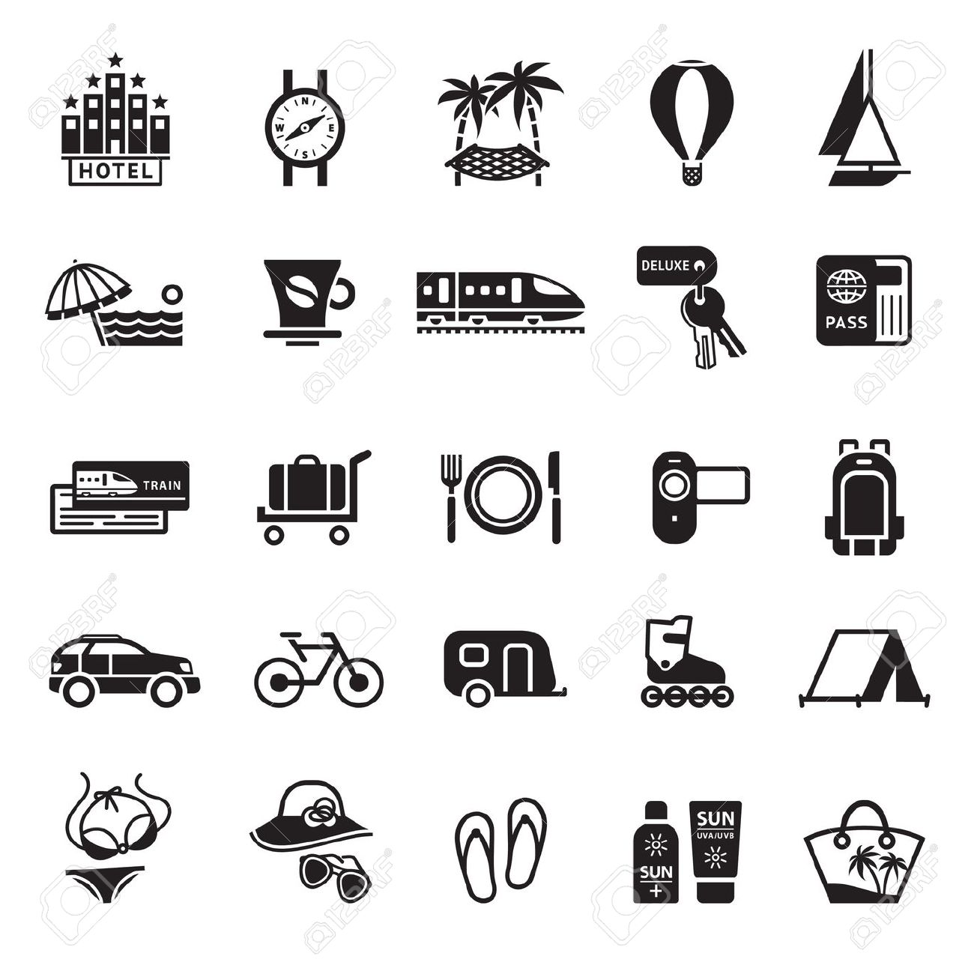](http://www.google.ca/url?sa=i&rct=j&q=&esrc=s&source=images&cd=&cad=rja&uact=8&ved=0CAcQjRw&url=http://www.123rf.com/stock-photo/tourism.html&ei=6_JIVeO_FYHloATH1IDABw&bvm=bv.92291466,d.cGU&psig=AFQjCNHm3Rt1RnrMwh2GZjOkwOM40uQPTQ&ust=1430930243284032)

#### Tourism, Hospitality, and Foods Program Requirements Possible Career Paths Focus Area and Placements

In addition to successful registration into WEX 12A/12B, the student is required to take four focus support courses, with at least two being at the Grade 12 level in order to receive credit for the course.

**Grade 11 Courses**

Media Design 11

Digital Media Development 11

Textiles 11

French 11

Leadership 11

Spanish 11

Peer Tutoring 11

Psychology 11

Senior Foods 11

Social Studies 11

Musical Theatre 11

Drama 11

Tourism 11

**Grade 12 Courses (at least 2)**

Media Design 12

Digital Media Development 12

Economics 12

Interpersonal & Family Relations 12

French 12

Leadership 12

Peer Tutoring 12

Psychology 12

Foods Studies 12

Spanish 12

Musical Theatre 12

Directing & Scriptwriting 12

Textiles 12



**Sample occupations**

• Anthropologist

• Librarian

• Language Teacher

• Museum Curator

• Urban Planner

• Communications Ofﬁcer

• Journalist

• Archivist

• Government Public Service

**Sample placements for this Focus Area through WEX 12A/12B:**

This Focus Area is for students who are interested in developing skills in customer service, tourism promotion, or understanding tourism’s value to the economy.

[](http://www.google.ca/url?sa=i&rct=j&q=&esrc=s&source=images&cd=&cad=rja&uact=8&ved=0CAcQjRw&url=http://pixshark.com/desk-bell-clip-art.htm&ei=U_VIVYCEBM3FogT5vIHwDA&bvm=bv.92291466,d.cGU&psig=AFQjCNEpvjKKtG9XKMOfxyfOpYAEf5P1KQ&ust=1430930965875720)

**What is a Focus Area?**

Focus Areas serve as organizers for students to plan their education in Grade 11 and 12 centered on an area of interest. By focusing on a certain area, students develop the technical and personal strengths, as well as employable skills, that will project them forward in future education or experience

**Career areas that match this Focus Area:**

* Hospitality
* Food Services
* Events and Conference Planning
* Tourism Services

**People in this Focus Area may have:**

• Interest in travel

• Interest in food preparation

• Interest in helping people

• Effective communication and personal management skills

• Demonstrating a positive attitude towards customers

• Ability to speak a second language

• Skills in food preparation, presentation or serving

• Customer service skills