#### WEX 12A/12B are courses offered to Grade 11 and 12 students and is a part of Delta’s Career Preparation program

#### Why take WEX 12A/12B?

#### Benefits of Work Experience (WEX) 12A/12B

* You gain 90 hours work experience in career field of choice
* You can use WEX hours to fulfill the 30 hours Work Experience /Community Service for Grad Transitions
* You receive the opportunity to develop employability skills
* You receive valuable real world feedback through employer assessment
* You can receive references and possible part-time or full-time employment

[](http://www.google.ca/url?sa=i&rct=j&q=&esrc=s&source=images&cd=&cad=rja&uact=8&ved=0CAcQjRw&url=http://4vector.com/free-vector/mechanic-clip-art-110275&ei=i89HVb2lD8zaoATfmoCQBw&bvm=bv.92291466,d.cGU&psig=AFQjCNGJUNkA-qoLP5xZy7ViQIxjW7L27Q&ust=1430855908910101)

**Burnsview Secondary School**



[](http://www.google.ca/url?sa=i&rct=j&q=&esrc=s&source=images&cd=&cad=rja&uact=8&ved=0CAcQjRw&url=http://pixshark.com/robots-clipart-black-and-white.htm&ei=KdBHVfioCYjooATIk4CADw&bvm=bv.92291466,d.cGU&psig=AFQjCNHVrnCOQucd_s7bM1OoVWlWJY7yoQ&ust=1430856091468105)

**For more information visit the website:** [**www.bucareerprograms.weebly.com**](http://www.bucareerprograms.weebly.com)

**Or contact:**

Virginia Dean, PhD

Career Programs Facilitator

vdean@deltasd.bc.ca

p. 604-594-0491 ext. 258

f. 604-594-0491

Burnsview Secondary

7658-112 Street

Delta, BC

V4C 4V8

**École Secondaire Burnsview**

Focus Area:

Trades and Technology

[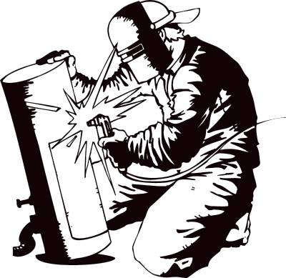](http://www.google.ca/url?sa=i&rct=j&q=&esrc=s&source=images&cd=&cad=rja&uact=8&ved=0CAcQjRw&url=http://www.clipartpanda.com/categories/welding-clipart&ei=vc5HVZykCorHogTa8IH4Cg&bvm=bv.92291466,d.cGU&psig=AFQjCNFWfUOblxA0ZeEdN2kjdYdOPjI9xQ&ust=1430855648164961)

Career Preparation Program

Courses:

Work Experience 12A/12B

#### Trades and Technology Program Requirements Possible Career Paths Focus Area and Placements

This Focus Area is for students who are interested in working in industrial and commericial trades as well as computer and information technologies.

[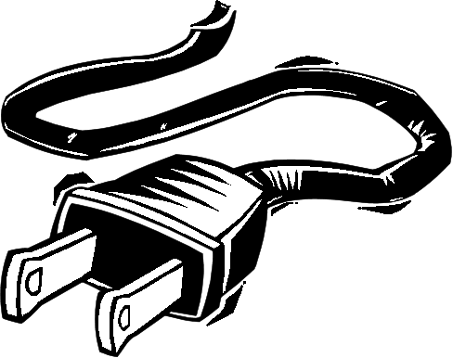](http://www.google.ca/url?sa=i&rct=j&q=&esrc=s&source=images&cd=&cad=rja&uact=8&ved=0CAcQjRw&url=http://www.wm8c.com/radio_clipart_-_electronics.htm&ei=oNFHVdHfJNPhoASNhIHoAQ&bvm=bv.92291466,d.cGU&psig=AFQjCNHE2omEy_1f-Rb7TeJAFla-GwuVBA&ust=1430856241649592)

**What is a Focus Area?**

Focus Areas serve as organizers for students to plan their education in Grade 11 and 12 centered on an area of interest. By focusing on a certain area, students develop the technical and personal strengths, as well as employable skills, that will project them forward in future education or experience

**Career areas that match this Focus Area:**

* Carpentry
* Mechanics
* Metal Work
* Welding
* Electronics
* Drafting and design
* Information Technology

**People in this Focus Area may have:**

• Interest in doing hands-on projects

• Interest in ﬁguring out how things work

• Interest in mechanical things

• Applied math skills that are relevant to industry applications

• Technical reading and writing skills

• Ability to locate information and understand updates to processes, codes, and regulations

• Applied science skills (e.g. applied physics)

• Safety skills, including a knowledge of safety rules and hazard identiﬁcation

• Understanding that use of technologies can affect the environment

• Critical thinking and problem solving while working on a project

In addition to successful registration into WEX 12A/12B, the student is required to take four focus support courses, with at least two being at the Grade 12 level in order to receive credit for the course.

**Grade 11 Courses**

Art Studio 12

Media Design 12

Woodwork 12

Digital Media Development 11

Textiles 11

Media Arts 11

Foundations of Math 11

Metalwork 11

Pre-Calculus Math 11

Robotics and Engineering 11

Food Studies 11

Musical Theatre 11

Drama 11

Youth in Trades

3D Modeling & Design 11

**Grade 12 Courses (at least 2)**

Art Studio 12

Woodwork 12

Media Design 12

Digital Media Development 12

Textiles 12

Media Arts 12

Foundations of Math 12

Metalwork 12

Physics 12

Pre-Calculus Math 12

Robotics and Engineering 12

Food Studies 12

Musical Theatre 12  
Directing & Scriptwriting 12

Youth in Trades

3D Modeling & Design

Theatre Performance 12: Directing

Youth in Trades

**Sample occupations**

• Plumber

• Carpenter or Cabinetmaker

• Pipe Fitter

• Electrician

• Instrumentation Mechanic

• Power Engineer

• Aircraft Maintenance Engineer

• Millwright

• Machinist

• Communications Repair Technician

• Welder

• Transit: Driver or Mechanic

• Heavy Equipment: Operator or Mechanic

**Sample placements for this Focus Area through WEX 12A/12B:**

- Alpha Aviation Airports

- Tech-Easy

