Focus Areas Assignment for Work Experience
Instructions: Answer the following questions in the space below.
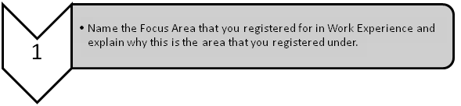
1.

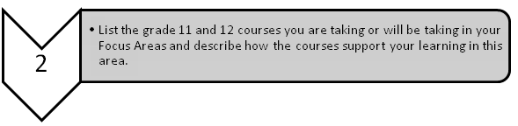
2.

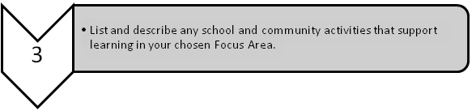
3.

Instructions: For questions 4 and 5 write reflections on what you discovered.
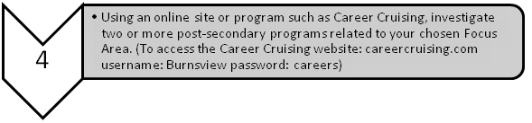
4.

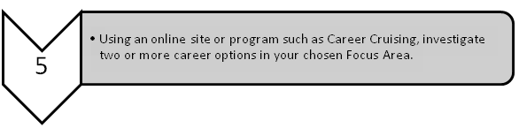
5.

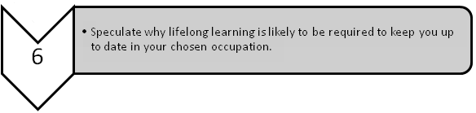
6.

