Workplace Ethics Assignment for Work Experience

Ethics are defined as “moral principles that govern a person’s or group’s behavior”. Workplace ethics can be defined as codes of conduct that influence the development of an ethical culture within the workplace.

What If’s: Answer the following questions in the space below from an ethical point of view.
1.

2.

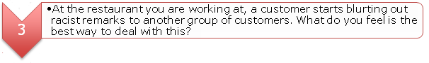
3.

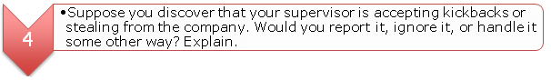
4.
5.

6.

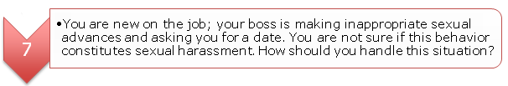
7.

8.

